Mall Integration GTO Support Tasks

Validating Zero Sales / Zero Sales Validation

Zero sales validation usually happens when we upload a GTO sales file that contains zero sales to the mall’s server, which the mall will then verify with us if the contents are correct.

- This task begins by the mall sending us a request to validate zero sales that they have received.
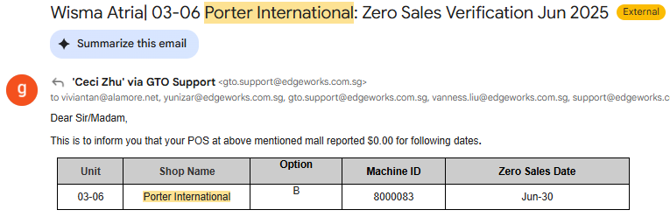
Take note of the important information regarding this task, such as the mall name (Wisma Atria), client/shop/store name (Porter International), and the date(s) of the missing sale(s) (June 30).

- We can verify the zero sales by heading over to the client’s Equipreport page and checking the daily sales report or transaction report for this date and outlet. For this example, head over to the daily sales report page (https://s2.equipweb.biz/SingaporePorterInternationalPteLtdreport/apps/DailySalesReport) and enter the necessary information, including the outlet name, start date, and end date.
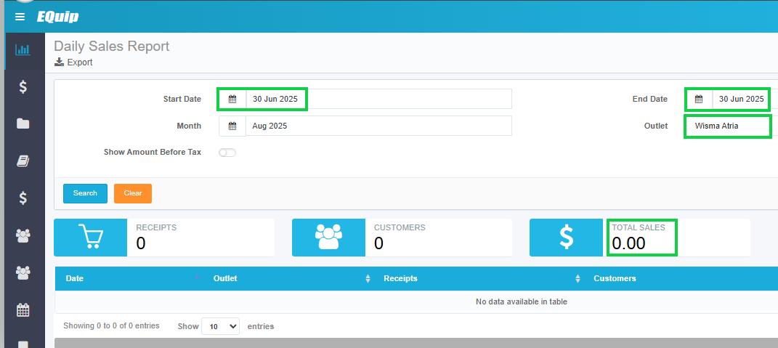
With the report above, we can see that there are indeed zero sales for that day, and that the GTO sales file that we have sent was valid.

- Since there are no sales for that day, we can reply to the mall’s email by stating that the zero sales that they have received is valid. If there are actually sales for the dates in question, we can follow the steps discussed below to send the missing files.

Resyncing Missing Sales
Missing sales tasks begin by malls’ emails requesting missing sales to be resent, such as one example below:
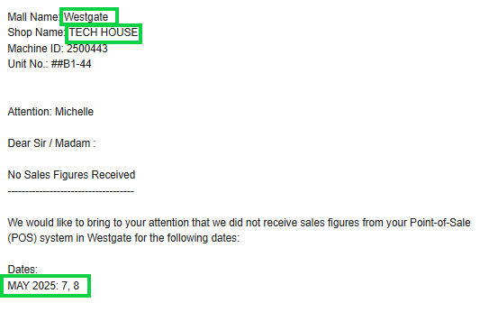

Take note of the important information regarding this task, such as the mall name (Westgate), client/shop/store name (Tech House), and the dates of the missing sales (May 07 to 08, 2025).
We must now determine where the task is hosted (linux server (integrator2 server), Web Server 2, or locally hosted).

Head over to Mall Integration and check the value under column D (“Exe location”).
Depending on the location where the task is hosted, there are different ways to generate and resend the missing sales. Let’s discuss the different locations and how to execute them.

Tasks on Linux Server (integrator2)

- Let us use the example above to go through the flow in the Linux server.

Take note of the important information regarding this task, such as the mall name (Westgate), client/shop/store name (Tech House), and the dates of the missing sales (May 07 to 08, 2025).

- Head over to the mall integration custom send Ansible task via this link:
https://semaphore.equipweb.biz/project/2/views/14/templates/124/tasks

- Click on the “RUN” button on the top right corner.
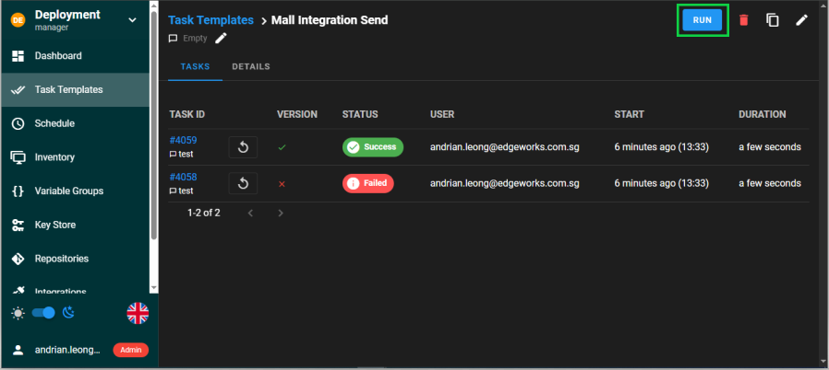

- On the pop-up window, fill in the details of the resync task.
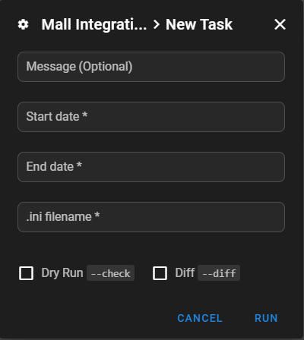
Start date: The start date (in YYYY-MM-DD format)
End date: The end date (in YYYY-MM-DD format)
.ini filename: The name of the configuration file, which can be found here:
Mall Integration under column E (.ini file name )

Using the example above, the values for this task are:
Start date: 2025-05-07
End date: 2025-05-08
.ini filename: tech_house_west_gate.ini
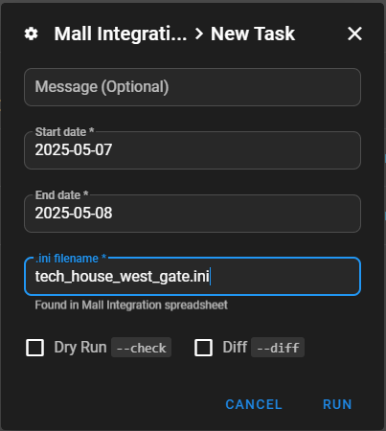
Once the details are filled, click on the “RUN” button.

- The files should now be resynced and sent to the mall’s server.
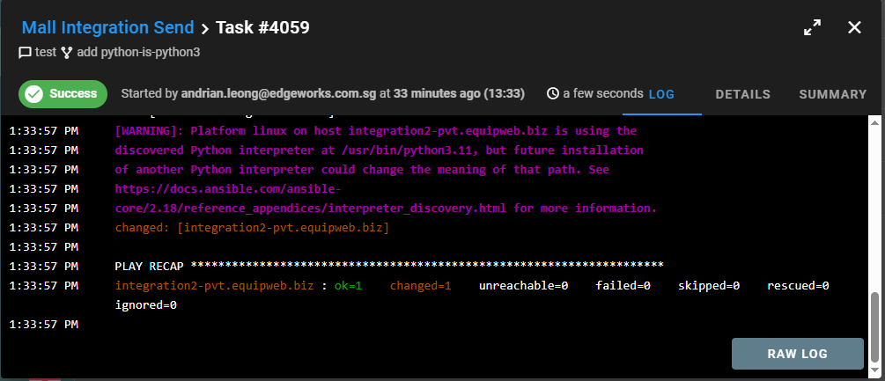

- We can then reply to the mall’s original email, stating that the sales files have been resent to their server.

Tasks on Web Server 2 (via RDP)

- Let us use a different example for a task that is hosted in Web Server 2.
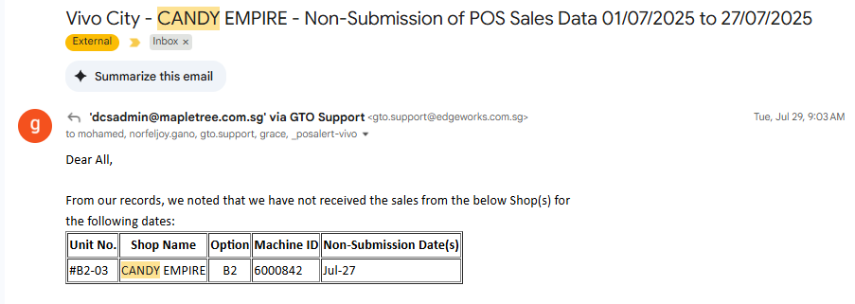
Take note of the important information regarding this task, such as the mall name (Vivo City), client/shop/store name (Candy Empire), and the dates of the missing sales (July 27, 2025).

- Connect to the Web Server 2 (172.31.38.22) using Remote Desktop Connection (RDP).
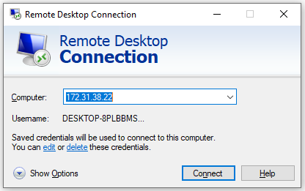

- Once inside, access the “C:\Integration” folder. Mall integration jobs hosted in Web Server 2 are listed here.
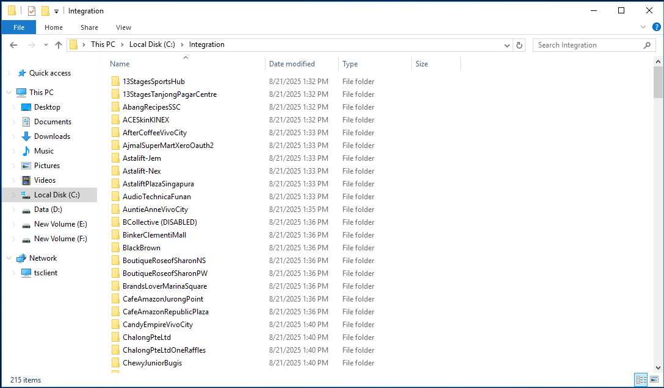

- Head inside the corresponding folder for the task, in this example, it would be “CandyEmpireVivoCity”.
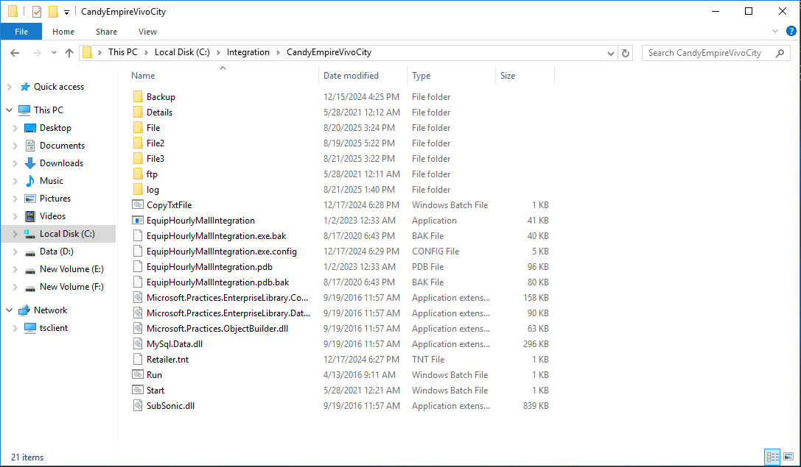

- Run the executable file (files with the string “Mall Integration” or “Mall Integrator” in its name) with Administrator privileges. In this example, it is the “EquipHourlyMallIntegration” file.

A pop-up window will appear. Fill in the “From” and “To” dates as required. In this example, it will be “July 27, 2025” for both dates.
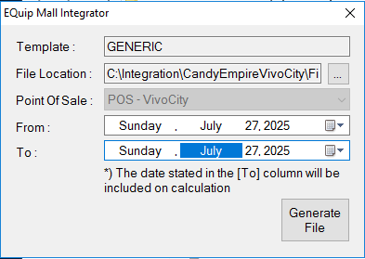
Then, click on the “Generate File” button.

- The program will now generate the files based on the selected dates. Once the files are generated, a pop-up window will show to notify that the execution has been completed.
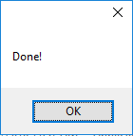

Take note of an important additional step!

If a file named “CopyTxtFile” exists within the folder, we must run this file first before proceeding to the next step.
If this file does not exist, we can proceed to the next step.
Since this file exists within the folder, execute this file with Administrator privileges.

- We are now ready to send the files to the mall’s server. Head inside the “ftp” folder.

Here, execute the “ftpupload” file with Administrator privileges.

The program will now begin uploading the files to the mall’s server.
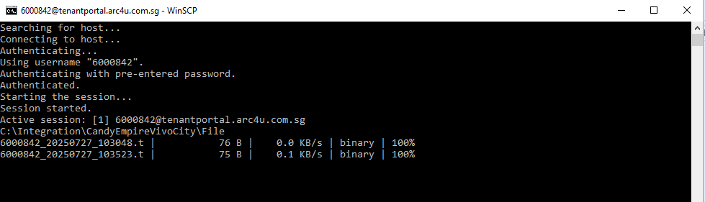
The program will automatically close once the files are uploaded.

- Finally, to exit, we can sign out of the Web Server 2.
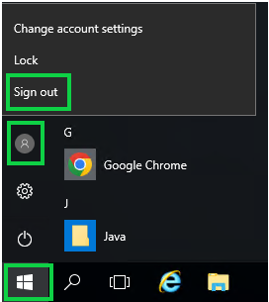

Tasks for Daiso (via AnyDesk)

GTO tasks for Daiso require us to connect to their PC via AnyDesk, as the program to resend the sales files are located in their PC.

- Install and open AnyDesk.
- Enter Daiso’s PC remote address in the address bar: 1402054034 and connect.
- Once connected, head over to the “C:\Edgeworks\MallIntegration” directory.
- Here, all the mall integrations are listed and categorized into their own separate folders.
- Open the corresponding mall folder that we wish to resend to.
- Open the “Equip Mall Integrator” executable.

- Insert the dates that we wish to resync from and to, and click on the “Generate File” button.
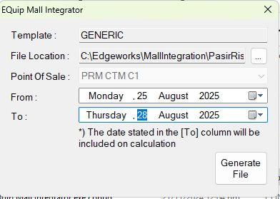

A window will popup to notify that the sales file generation is done.
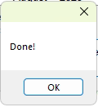
Click on “OK” and close the Equip Mall Integrator” executable

- Take note of an important additional step!
or
If a file named “CopyTxtFile” or “Copy only.bat” exists within the folder, we must run this file first before proceeding to the next step.
If this file does not exist, we can proceed to the next step.
Since this file exists within the folder, execute this file.

- Head over to the FTP folder, and run the “ftpupload.bat” script.

- The generated sales files will now be uploaded to the mall’s server.
- Finally, to end the session, we can lock the PC.
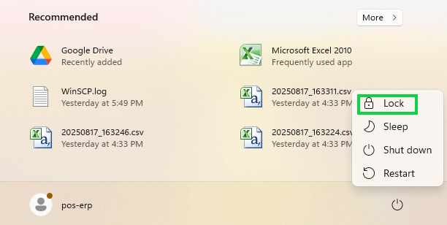

Tasks Hosted Locally (e.g. Muji Cafe)

There are some tasks that are locally hosted on the client’s own PC, such as (but not limited to) Daiso or Muji Cafe. In this section, let's discuss the steps for generating the sales file for Muji Cafe.

- Install and open AnyDesk.
- Enter their remote address in the address bar: 634674157, and use the password Werasd90 when prompted.
- Once connected, head over to the “C:\Edgeworks\Integration” directory.
- Here, all the mall integrations are listed and categorized into their own separate folders.
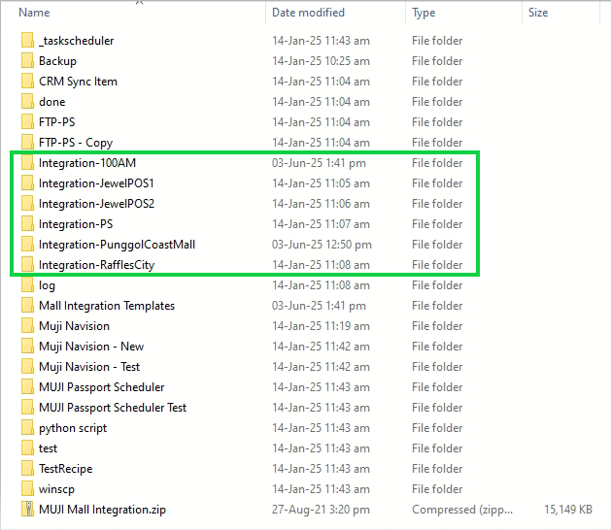

- Navigate to the required integration folder. In this example, let us use “Integration-100AM” (for 100AM Mall).
- Run the executable file (files with the string “Mall Integration” or “Mall Integrator” in its name) with Administrator privileges. In this example, it is the “EQuip Mall Integrator” file.
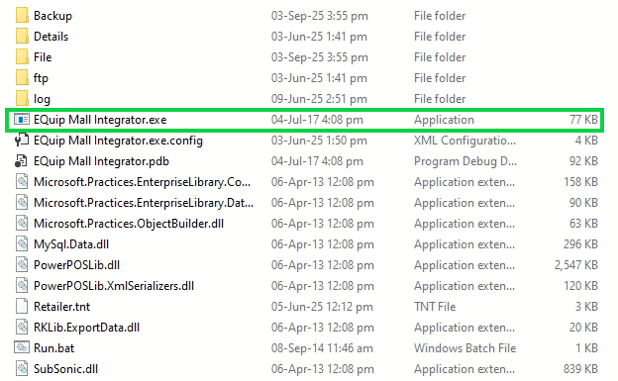

- A pop-up window will appear. Fill in the “From” and “To” dates as required.
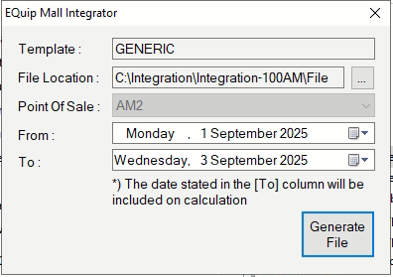
Then, click on the “Generate File” button.

- The program will now generate the files based on the selected dates. Once the files are generated, a pop-up window will show to notify that the execution has been completed.


- We are now ready to send the files to the mall’s server. Head inside the “ftp” folder.

Here, execute the “ftpupload” file with Administrator privileges.

The program will now begin uploading the files to the mall’s server.
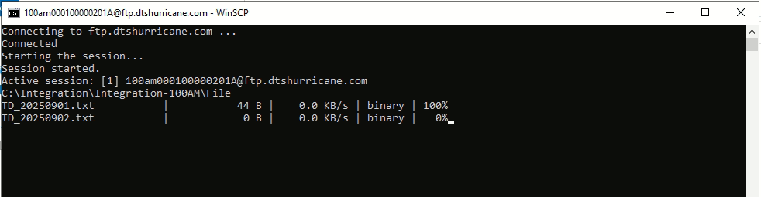
The program will automatically close once the files are uploaded.

